**Information Manual**

**For**

**Minor Project**



**Parul Institute of Engg. & Tech**

**Parul University**

**Department of Mechanical Engineering**

**Year / Semester: 3nd Year / 6th Semester**

**Academic year: 2017-2018**

**Conducted by: SHIVANI DESAI Prepared by**: **KHATRA JAYRAJ**

**KATARIYA NIESH**

**KUKADIYA DIXIT**

**PARUL INSTITUTE OF**

**ENGINEERING &TECHNOLOGY**



**CERTIFICATE**

This is to Certified that this project report “**FOUR WHEEL STEERING SYSTEM**” is submitted by “**KHATRA JAYRAJ, KATARIYA NIMESH, KUKADIYA DIXIT**” who carried out the project work under my supervision.I approve this project for submission of the Bachelor of Engineering in the Department of Mechanical Engineering, Parul Institute Of Technology, Faculty of Engineering and Technology, Parul University, Vadodara (GUJARAT).

|  |  |  |
| --- | --- | --- |
| Prof. Mohsin Dadi | Asst.Prof. Shivani desai |  |
| **(HOD, MECH)** | **(Project Coordinator)** |  |

**ACKNOWLEDGEMENT**

It gives me immense pleasure to express my deepest sense of gratitude and sincere thanks to my highly respected and esteemed guide **ASST. PROF. SHIVANI DESAI (Mechanical** **Engineering)**, PIET , PU Vadodara, for their valuable guidance, encouragement and help for completing this work. Their useful suggestions for this whole work and co-operative behavior are sincerely acknowledged.

I would like to express my sincere thank to **Prof. Manish Pandya , Principle PU, Vadodara** for giving me this opportunity to undertake this project.

I also wish to express my gratitude to **Asst. Mohsin Dadi HOD (Mechanical** **Engineering)** for his kind hearted support.

I also wish to express my indebtedness to my parents as well as my family member whose blessings and support always helped me to face the challenges ahead.

At the end I would like to express my sincere thanks to all my friends and others who helped me directly or indirectly during this project work.

**Place:** Vadodara

**FOUR WHEEL STEERING SYSTEM**

**Class: TD-7 (Batch-B- Mechanical Department)**

**Team members: Khatra Jayraj,**

**Katariya Nimesh &**

**Kukadiya Dixit.**

**Enrollment no.: 150304109043,**

**150304109045 &**

**150304109047.**

**Abstract**

A Four Wheel steering (4WS) System is also known as “Quadra Steering System”. In this paper, both front as well as rear wheels can be steered according to speed of the vehicle and space available for turning. Quadra steer is system that gives full size vehicles greater ease while driving at low speed, and improves stability, handling and control at higher speed. Quadra steering system works in following three phases Negative phase, Neutral phase, Positive phase. It enables the car to be steered into tighter parking spaces. It makes the car more stable at speed (less body roll). It makes the car more efficient and stable on cornering, easier and safer lanes change when on motorways. The steering system allows the driver to guide the moving vehicle on the road and turn it right or left as desired. The main aim is that turning of the vehicle should not require greater efforts on the part of the driver. The Quadra steer steering system offers a 21% reduction in turning radius. So if a vehicle is capable of making a U-turn in a 25-foot space, Quadra steer allows the driver to do it in about 20 feet.**INTRODUCTION**

**What is Steering?**

**Steering** is the term applied to the collection of components, linkages, etc. which will allow a vessel (ship or Boat) or vehicle to follow the desired course. An exception is the case of rail transport by which rail tracks combined together with railroad switches provide steering column, which may contain universal joints, to allow it to deviate somewhat from a straight line. The steering function. The most conventional steering arrangement is to turn the front wheels using a hand–operated steering wheel which is positioned in front of the driver.

**Types of Steering System:**

**CONVENTIONAL STEERING SYSTEM:**

In that steering system, only the front wheels are steered towards right or left According to the requirement because of at rear their dead axle is present.

**FOUR WHEEL STEERING SYSTEM:**

In that steering system, the all four wheels are to be steered according to the steer perform to drive towards left or right. Four-wheel steering, 4WS, also called rear-wheel steering or all-wheel steering, provides a means to actively steer the rear wheels during turning maneuvers. It should not be confused with four-wheel drive in which all four wheels of a vehicle are powered. It improves handling and helps the vehicle make tighter turns. Production-built cars tend to under steer or, in few instances, over steer. If a car could automatically compensate for an under steer /over steer problem, the driver would enjoy nearly neutral steering under varying conditions. In most active four wheel steering system, the rear wheels are steered by a computer and actuators, the rear wheels generally cannot turn as far as the front wheels. Some systems including Delphi’s Quadra steer and the system in Honda’s Prelude line allow the rear wheels to be steered in the opposite direction as the front wheels during low speeds. This allows the vehicle to turn in a significantly smaller radius sometimes critical for large tucks or tractors and

vehicles with trailers.

**Purpose of Automotive Steering System:**

The purpose of the steering system allows the driver to control the direction of the vehicle by turning the front wheels. The steering system consists of the following component parts.

**Requirements of steering system:**

The steering system has the following requirements.

1. Excellent maneuverability when the vehicle is cornering on a narrow, twisting road, the steering system must be able to turn the front wheels sharply yet easily and smoothly.

2. Proper steering effort if nothing is done to prevent it, steering effort will be greater when the vehicle is stopped and will decrease as the speed of the vehicle increase. Therefore, in order to obtain easier steering and better feel of the road, the steering should be made lighter at low speeds and heavier at high speeds.

3. Smooth recovery while the vehicle is turning, the driver must hold the steering wheel firmly. After the turn is completed, however, recovery – that is, the return of the wheels to the straight-ahead position – should occur smoothly as the driver relaxes the force with which he is turning the steering wheel.

4. Minimum transmission of shock from road surface Loss of steering wheel control and transmission of kickback due to road surface roughness must not occur.

**Why Four-Wheel Steering System?**

To understand the advantages of four-wheel steering, it is wise to review the dynamics of typical steering maneuvers with a conventional front -steered vehicle. The tires are subject to the forces of grip, momentum, and steering input when making a movement other than straight ahead driving. These forces compete with each other during steering maneuvers. With a front steered vehicle, the rear end is always trying to catch up to the directional changes of the front wheels. This causes the vehicle to sway. As a normal part of operating a vehicle, the driver learns

to adjust to these forces without thinking about them.

When turning, the driver is putting into motion a complex series of forces. Each of these must be balanced against the others. The tires are subjected to road grip and slip angle. Grip holds the car's wheels to the road, and momentum moves the car straight ahead. Steering input causes the front wheels to turn. The car momentarily resists the turning motion, causing a tire

slip angle to form. Once the vehicle begins to respond to the steering input, cornering forces are generated. The vehicle sways as the rear wheels attempt to keep up with the cornering forces already generated by the front tires. This is referred to as rear-end lag, because there is a time delay between steering input and vehicle reaction. When the front wheels are turned back to a straight -ahead position, the vehicle must again try to adjust by reversing the same forces developed by the turn. As the steering is turned, the vehicle body sways as the rear wheels again try to keep up with the cornering forces generated by the front wheels.

**STEERING CONDITIONS**

**1 Normal steering**



Idle position

  
Right turn



Left turn

**2. Four wheel steering:**



Extreme left



Extreme right

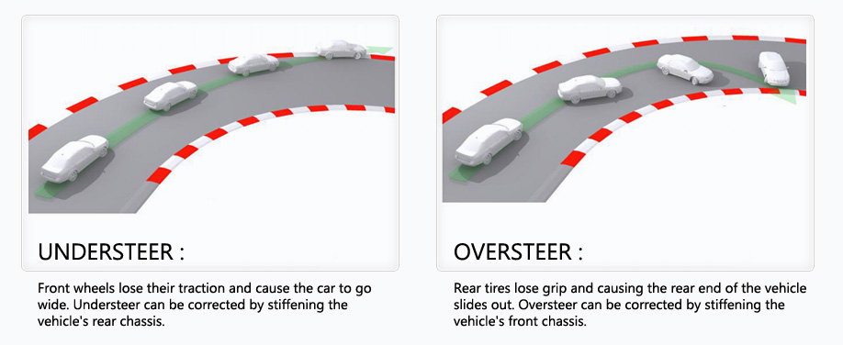

**Comparison Of Four Wheel Steering System With Two Wheel Steering Conventional System**

1. Car more efficient and stable on cornering.

2. Improved steering responsiveness and precision.

3. High speed straight line stability.

4. Notable improvement in rapid, easier, safer lane changing maneuvers.

5. Smaller turning radius and tight space maneuverability at low speed.

6. Relative Wheel Angles and their Control.

7. Risk of hitting an obstacle is greatly reduced



**Advantages**

1. Superior cornering stability.

2. Improved steering responsiveness and precision.

3. High speed straight line stability.

4. Notable improvement in rapid lane changing maneuvers.

5. Smaller turning radius and tight space maneuverability at low speed.

6. Relative wheel angles and their control.

**APPLICATIONS**

1. Parallel parking: Due to smaller turning radius the parking and un parking of vehicle is easily performed towards the right or left side.

2. High speed lane changing: In this is less steering sensitive this does require a lot of concentration from driver since he has to judge the space and vehicles behind them.

3. Slippery road surfaces: Due to the rear wheel steering operation on low friction surfaces occurs hence vehicle direction easier to control.

4. Narrow Roads: Due to rear wheel steering on narrow roads with tight bends, counter phase steering reduces the turning radius.

5. U-Turns: By minimizing the vehicle’s turning radius and counter phase steering of rear wheels enables U-Turns to be performed on narrow roads.

**CONCLUSION**

Thus, the four wheel steering system has got cornering capability, steering response, straight-line stability, lane changing and low speed maneuverability. Even though it is advantageous over the convectional two wheel steering system, four wheel steering is a complex and expensive. Currently the cost of a vehicle with four wheel steering is more than that of the convectional two wheel steering of vehicle. Four wheel steering is growing in popularity and it is likely to come in more and more new vehicles. As the system become more common place, the cost of four wheel steering system will drop down.

**FUTURE ASPECTS**

An innovative feature of this steering linkage design is its ability to drive all four Wheels using a single steering actuator. Its successful implementation will allow for the development of a four-wheel, steered power base with maximum maneuverability, uncompromised static stability, front- and rear-wheel tracking, and optimum obstacle climbing capability. The advanced system of “Four wheel steering” will work electronically with the help or microprocessors. The system will utilize an onboard computer to control and direct the turning left and right of the rear wheels.